AWS Restart

Supplementary Lab Guide

**267 Build Your VPC and Launch a Web Server Build Your VPC and Launch a Web Server(simplified)**

# Introduction

This guide is an attempt to simplify the act of creating an EC-2 Website using a VPC as required in the Labs 267.

# Objectives

After completing this lab, you should be able to:

* Create a virtual private cloud (VPC)
* Create subnets
* Configure a security group
* Launch an Amazon Elastic Compute Cloud (Amazon EC2) instance into a VPC

# Solution Overview

We will create a VPC a Subnet and place the Ec-2 instance inside the subnet.

We will also install a webserver on the EC-2 instance and access it using a web browser/

## Step -1

1 Create the VPC with the CIDR Block Range 10.0.0.0/16 (65000 Hosts).

2.Create an Internet Gateway and attach it to the newly created VPC

3.Create Public Subnet -1 in Availability zone -1 with the CIDR 10.0.0.0/24

4.Create Private Subnet -1 in Availability Zone -1 with CIDR of 10.0.1.0/24

5.Create an Elastic IP.

6.Create a NAT Gateway using the Elastic IP using the Public Subnet -1 as base

7.Create Public Subnet -2 in Availability zone -2 with the CIDR 10.0.2.0/24

8.Create Private Subnet -2 in Availability Zone -2 with the CIDR 10.0.3.0/24

9.Update Route Configurations for present Route Table and name it Private Route Table

10.Create Public Route Table and update Route Configurations .

11.Create VPC Security Group to allow inbound HTTP,HTTPS and SSH

12.Create EC-2 Instances using the VPC Created as Base and the Public Subnet -1 as EC-2 Location.

13.Enable Public IP for the EC-2

15.Associate the VPC Security Group for the EC-2

14.Update User Data for the EC-2

15.Launch EC-2

16.Test Webserver running on EC-2 using a browser.

Following the steps mentioned above the Lab can be completed successfully using the following guided path.

### 1 Create the VPC with the CIDR Block Range 10.0.0.0/16 (65000 Hosts).

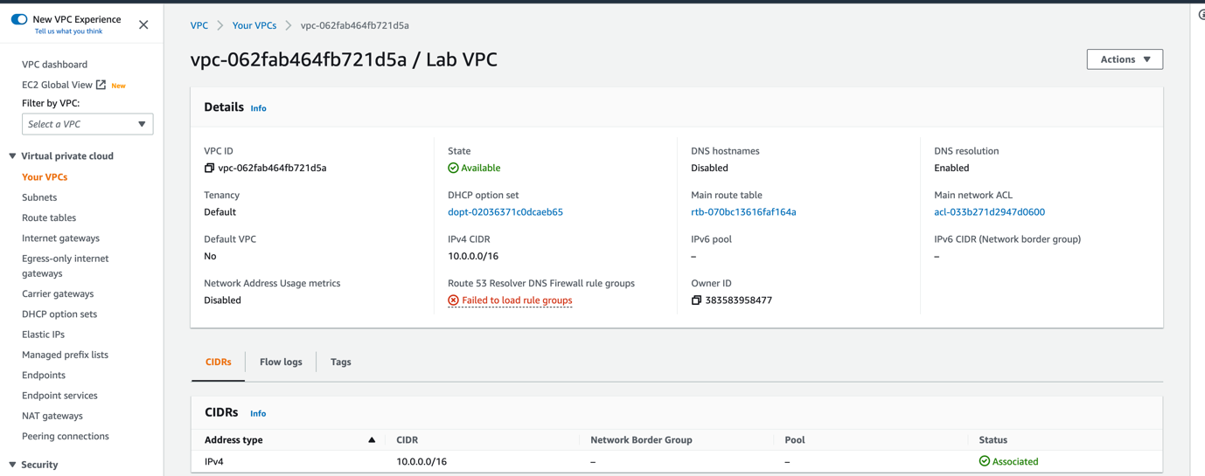

2.Create an Internet Gateway and attach it to the newly created VPC

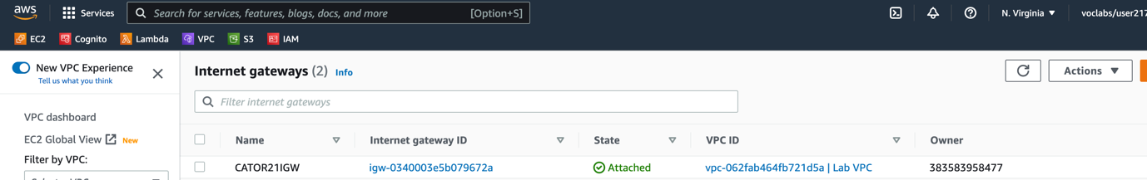

3.Create Public Subnet -1 in Availability zone -1 with the CIDR 10.0.0.0/24

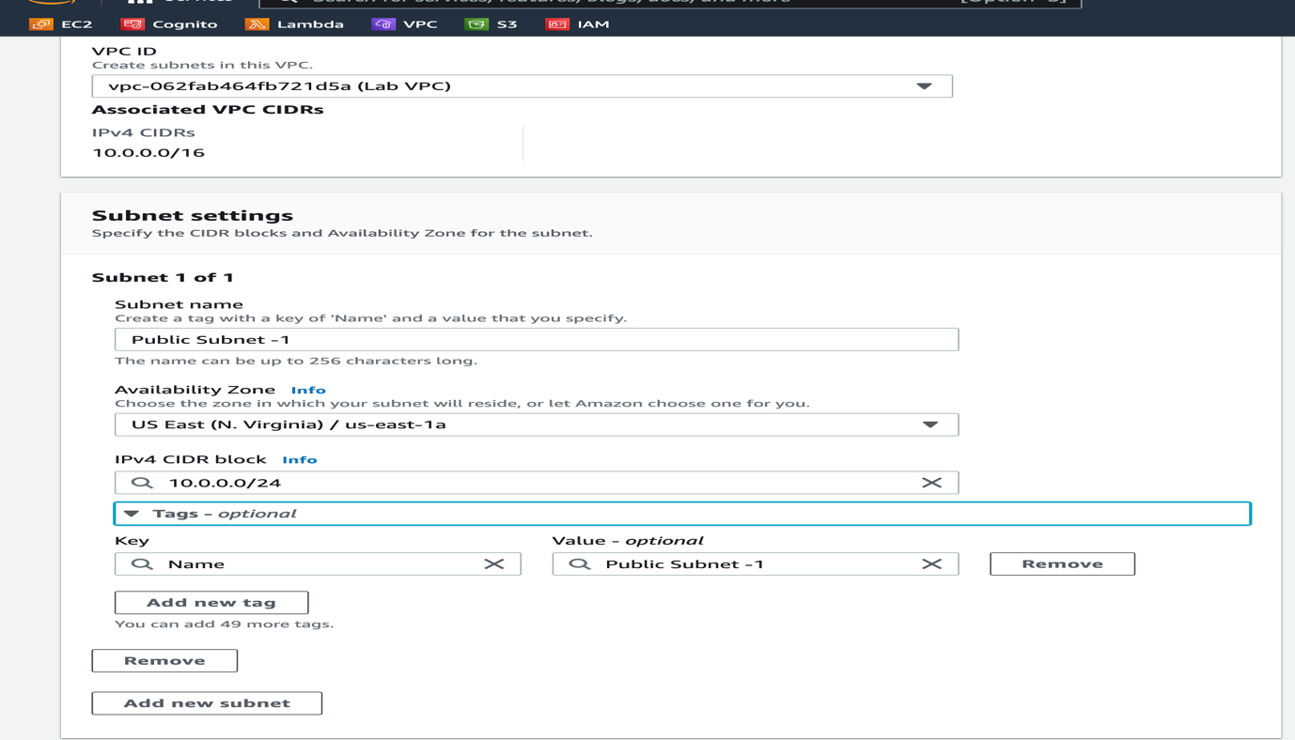

4.Create Private Subnet -1 in Availability Zone -1 with CIDR of 10.0.1.0/24

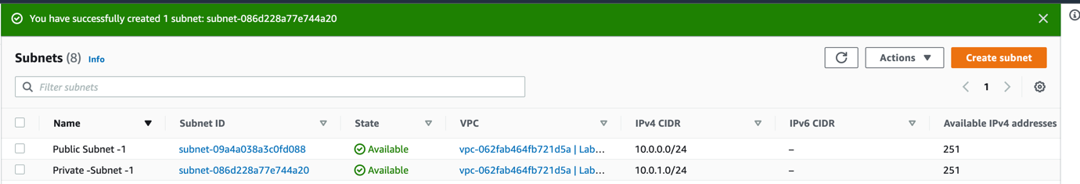

5.Create an Elastic IP.

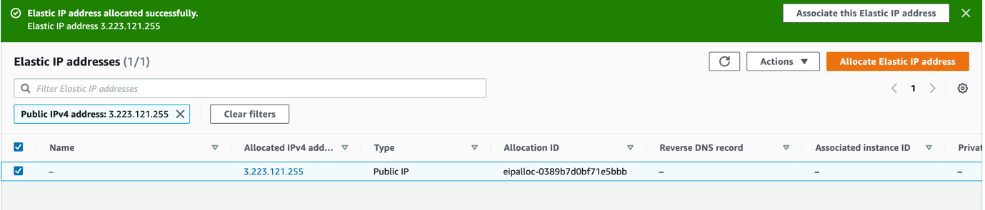

6.Create a NAT Gateway using the Elastic IP using the Public Subnet -1 as base

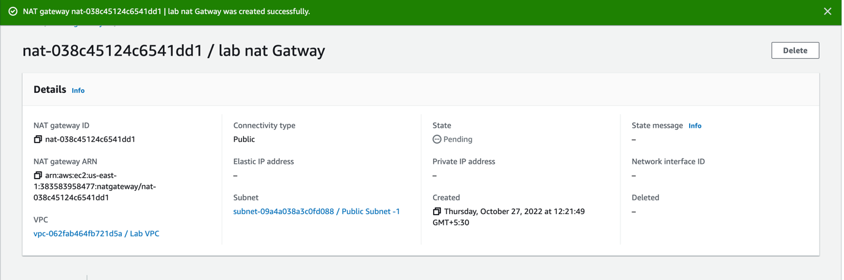

7.Create Public Subnet -2 in Availability zone -2 with the CIDR 10.0.2.0/24

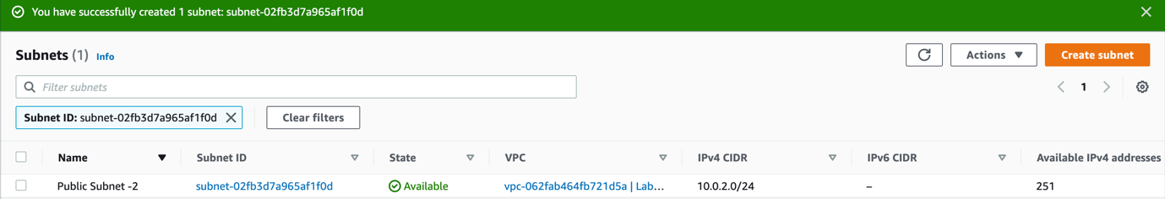

8.Create Private Subnet -2 in Availability Zone -2 with the CIDR 10.0.3.0/24

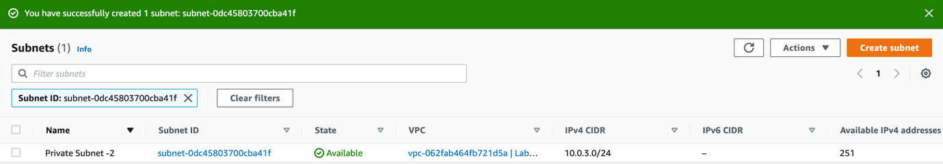

9.Update Route Configurations for present Route Table and name it Private Route Table

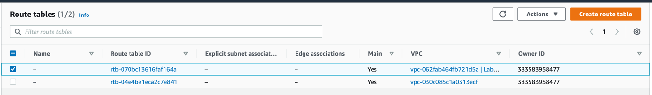

Update Private Route Table Route’s as follows

|  |  |
| --- | --- |
| Destination | Target |
| 10.0.0.0/16 | Local |
| 0.0.0.0/0 | NAT Gateway |

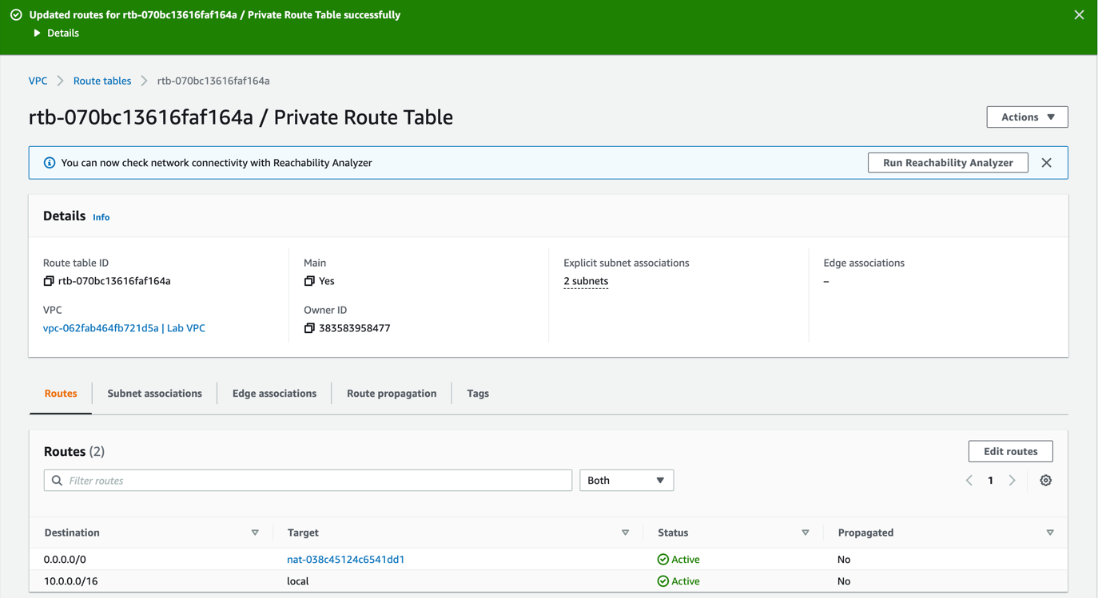

Edit Subnet Association

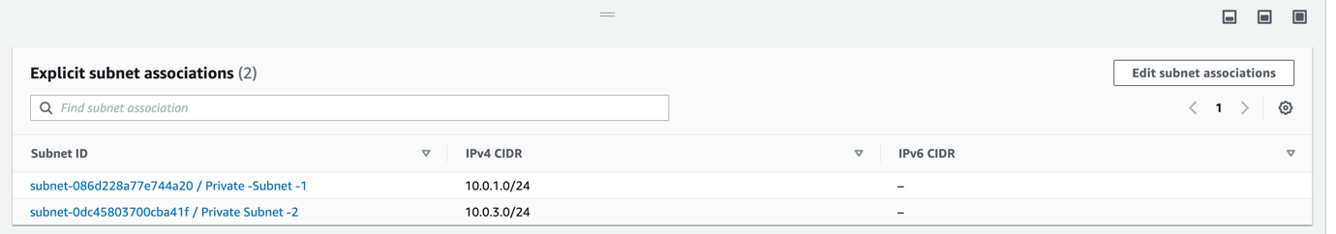

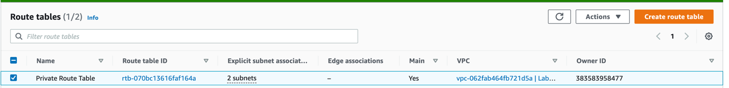

10.Create Public Route Table and update Route Configurations .

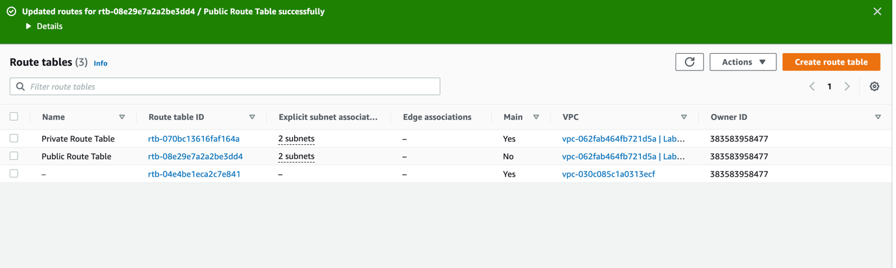

11.Create VPC Security Group to allow inbound HTTP,HTTPS and SSH

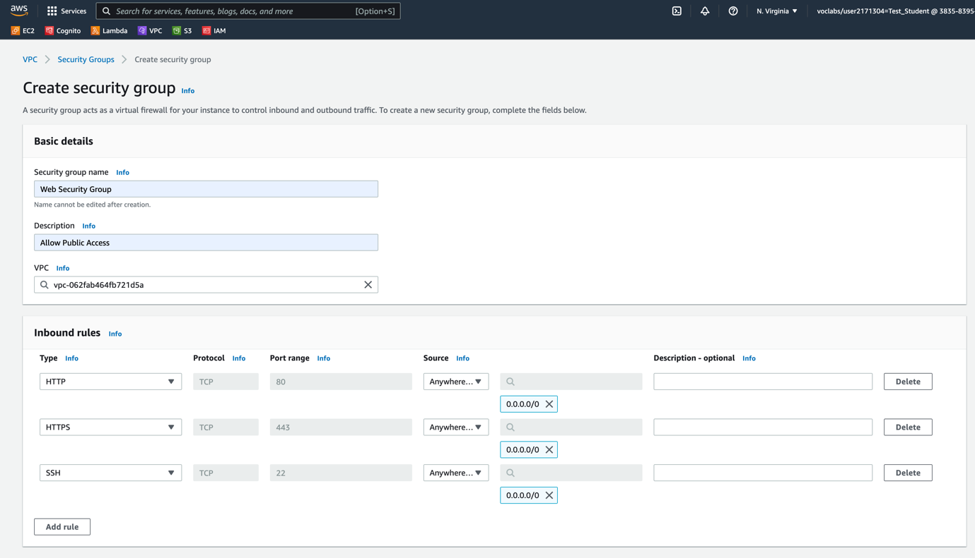

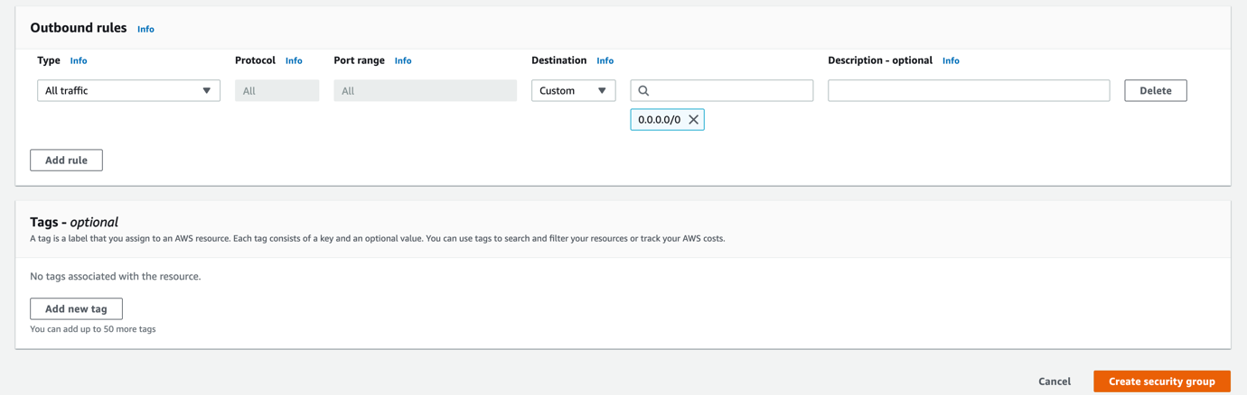

12.Create EC-2 Instances using the VPC Created as Base and the Public Subnet -1 as EC-2 Location.

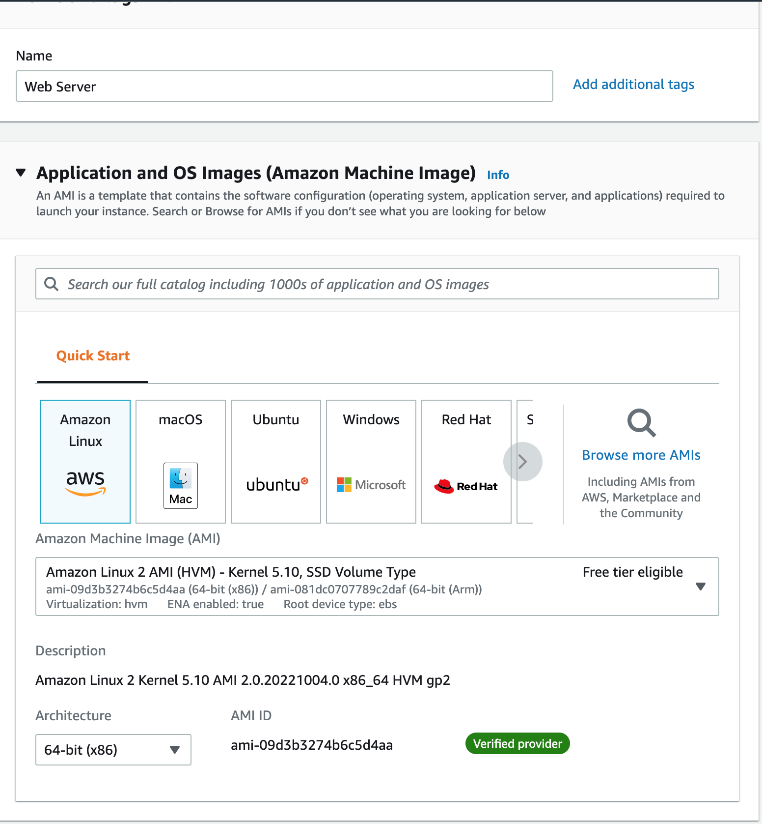

13.Enable Public IP for the EC-2

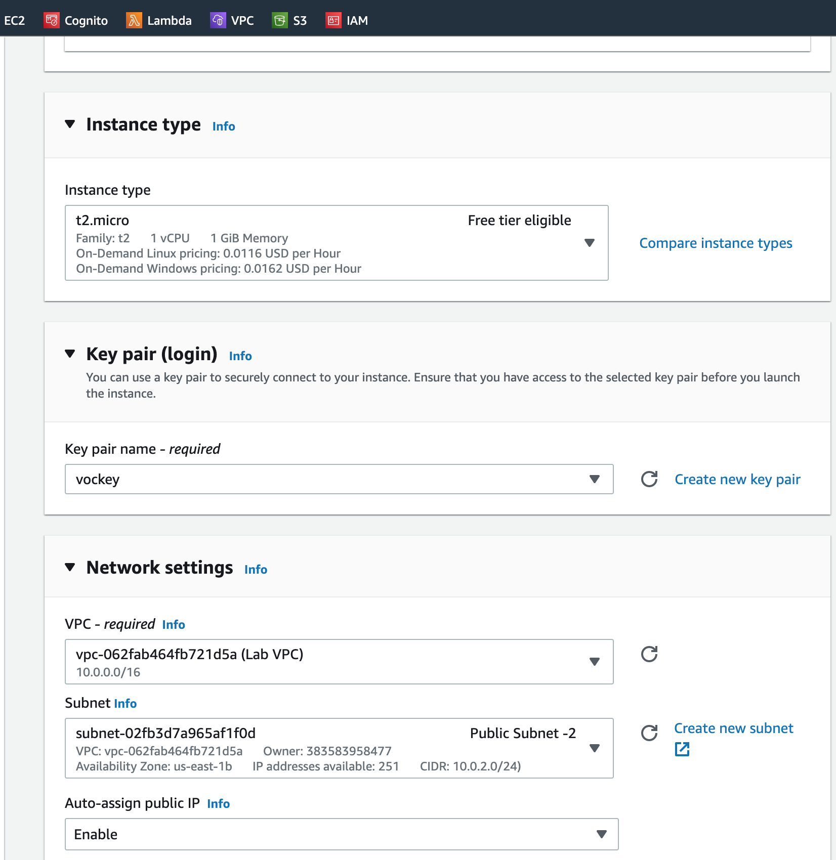

15.Associate the VPC Security Group for the EC-2

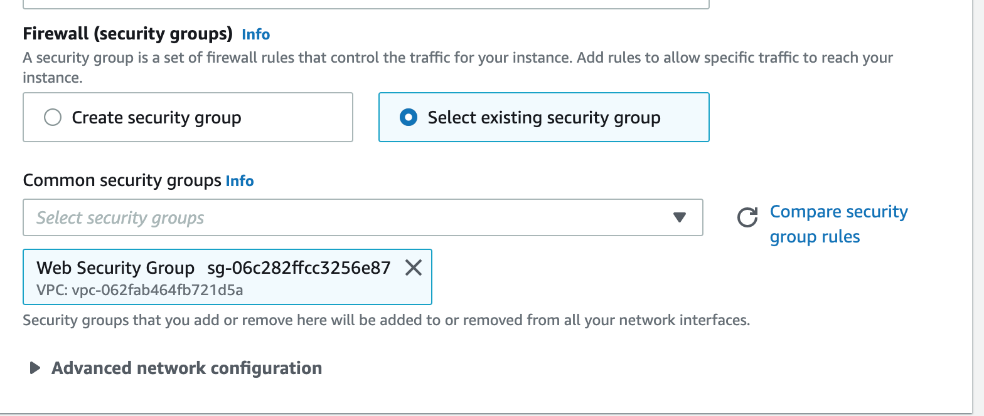

14.Update User Data for the EC-2

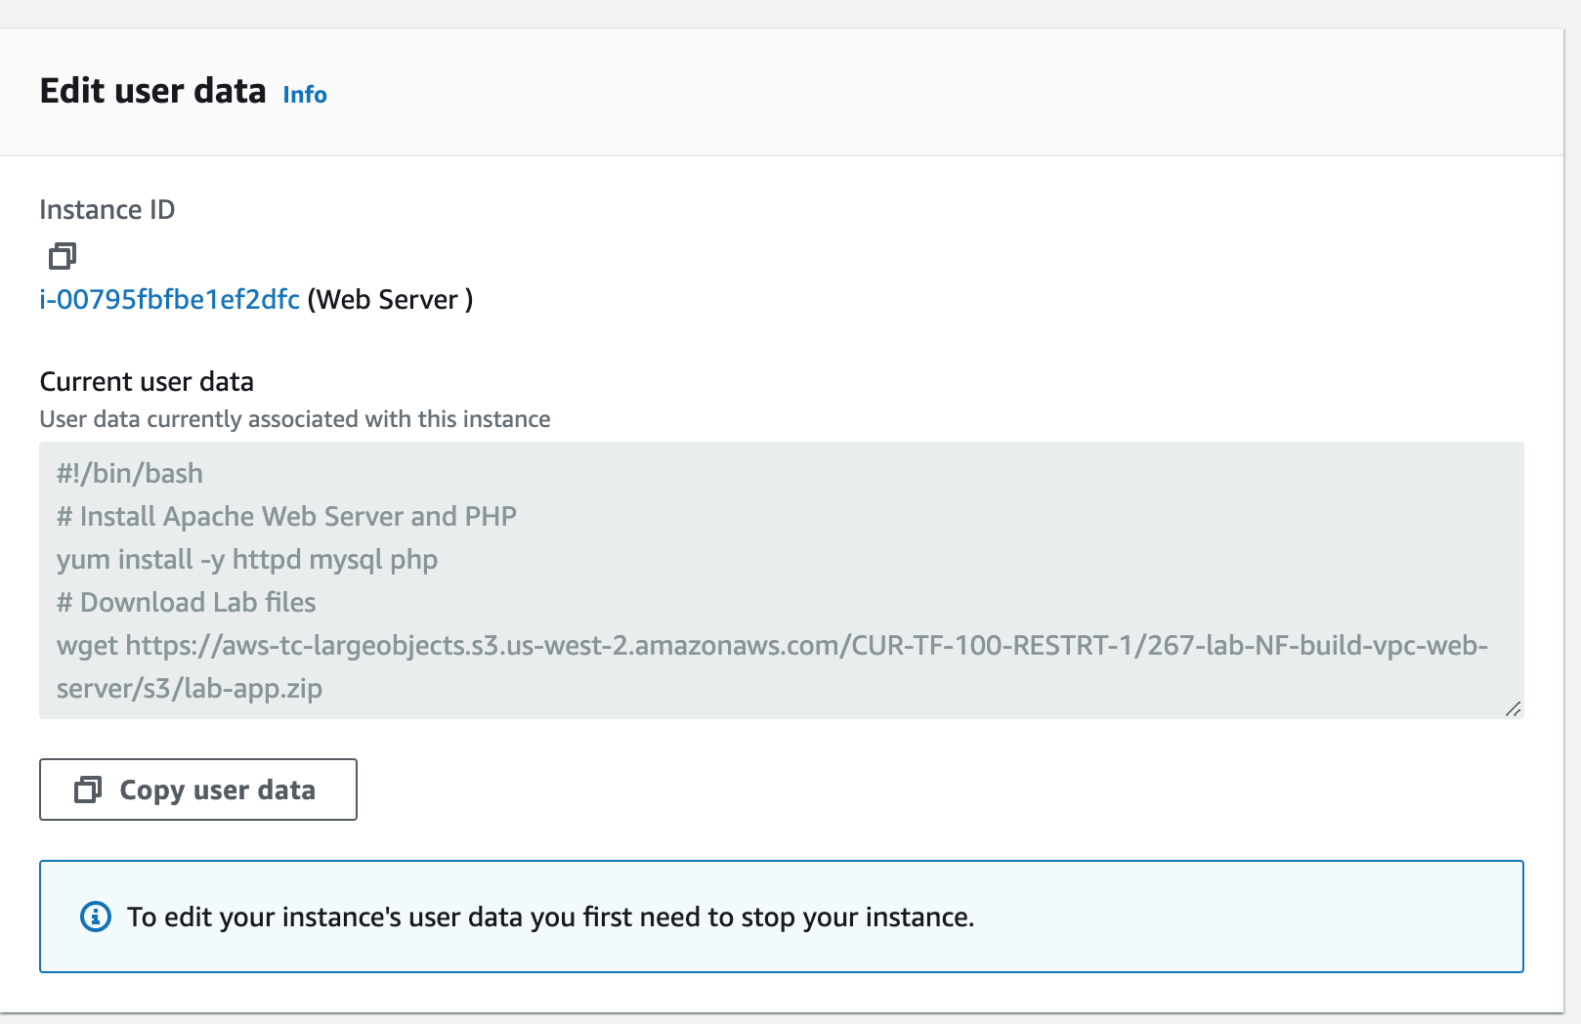

15.Launch EC-2

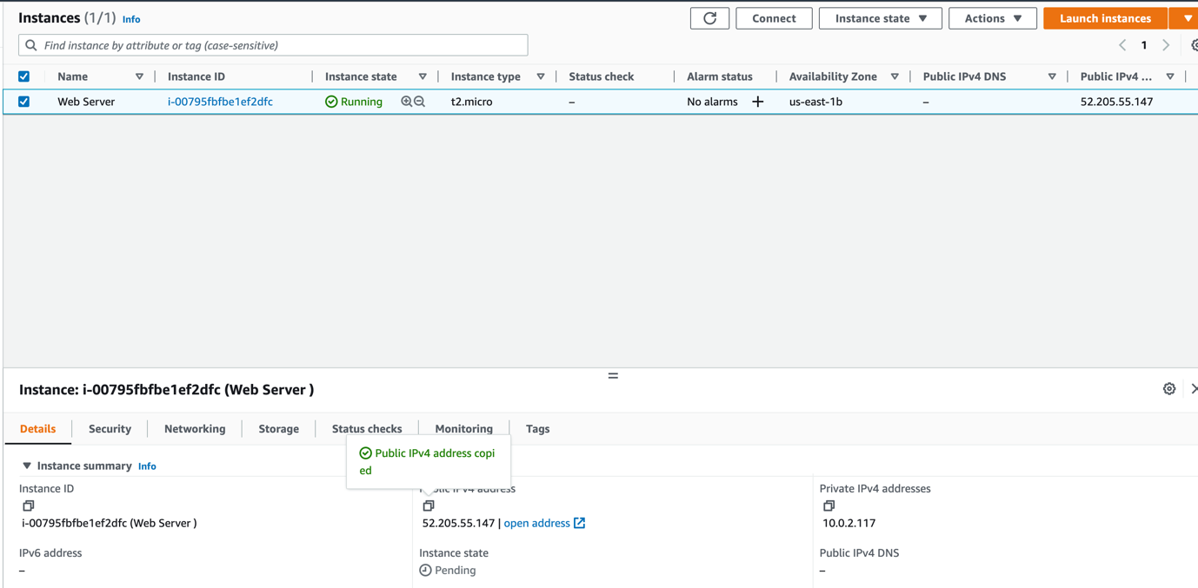

16.Test WebServer running on EC-2 using a browser.

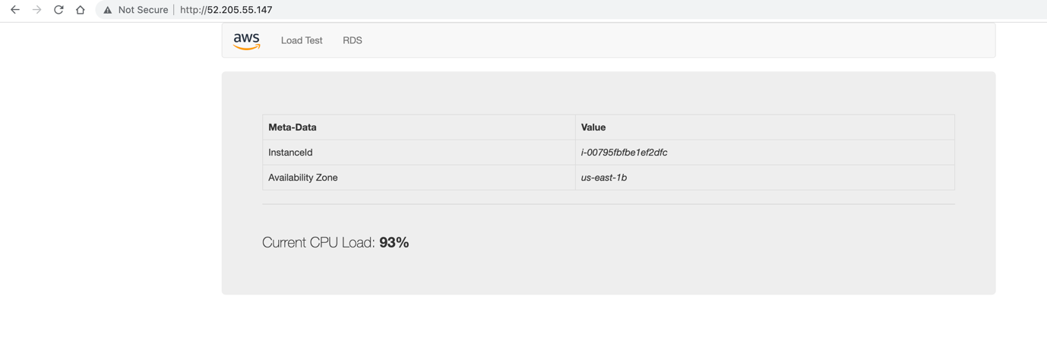

**LAB Complete**